Create a CI/CD Pipeline

Step 1: Go to Azure DevOps portal <https://dev.azure.com> .

Step 2: Click on start free and give the credentials of Microsoft account

**Note : You can use your personal Microsoft account or Capgemini Microsoft account which should have a valid subscription.**

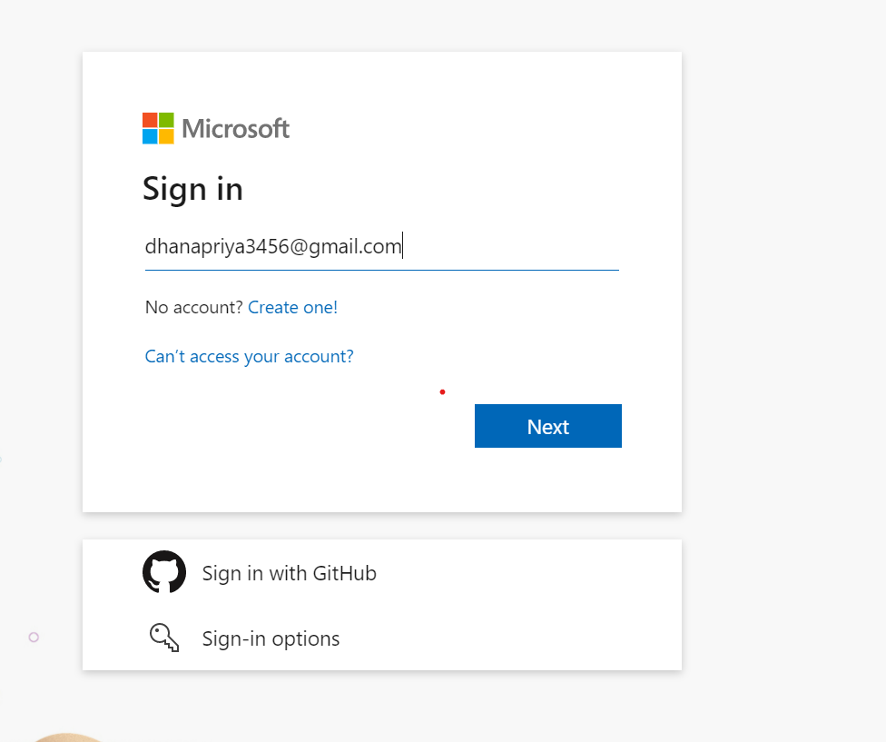

**S**tep 3: If your are new to the Azure DevOps Create an Organization

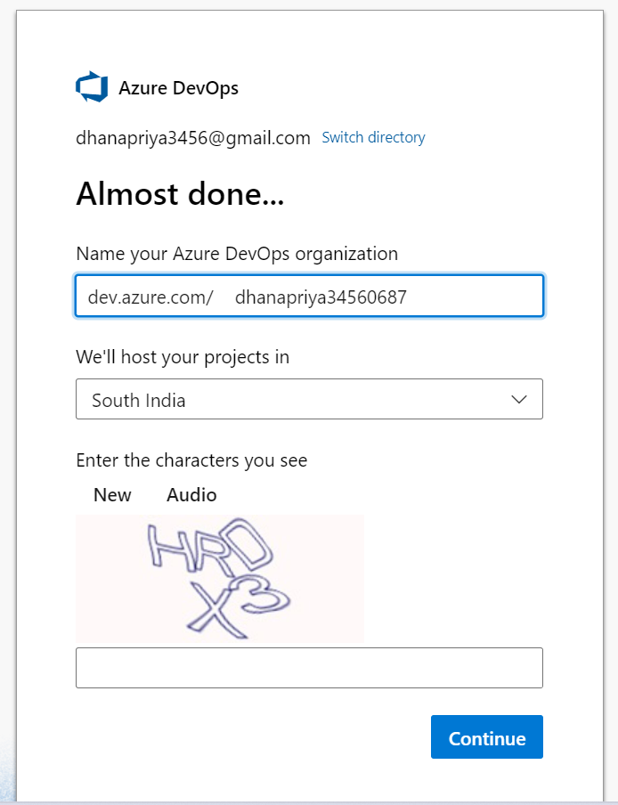

Step 4: After Creating the Organization Under this Create a project in public or private visibility according to the project requirement.

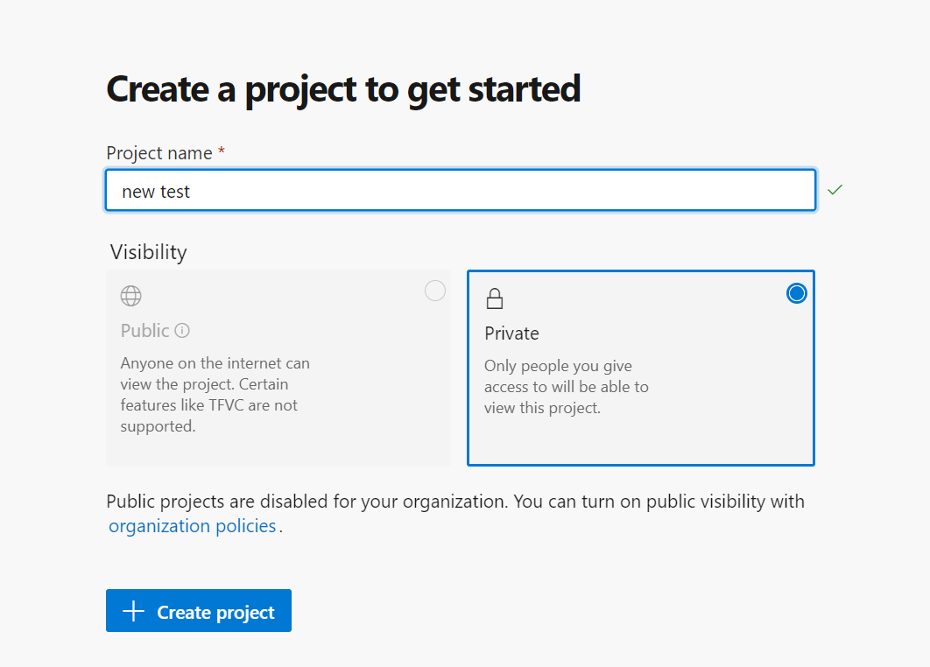

Step 5: In that project you can create Work items and Boards ( like giving the task or issue your working and the state of the task)

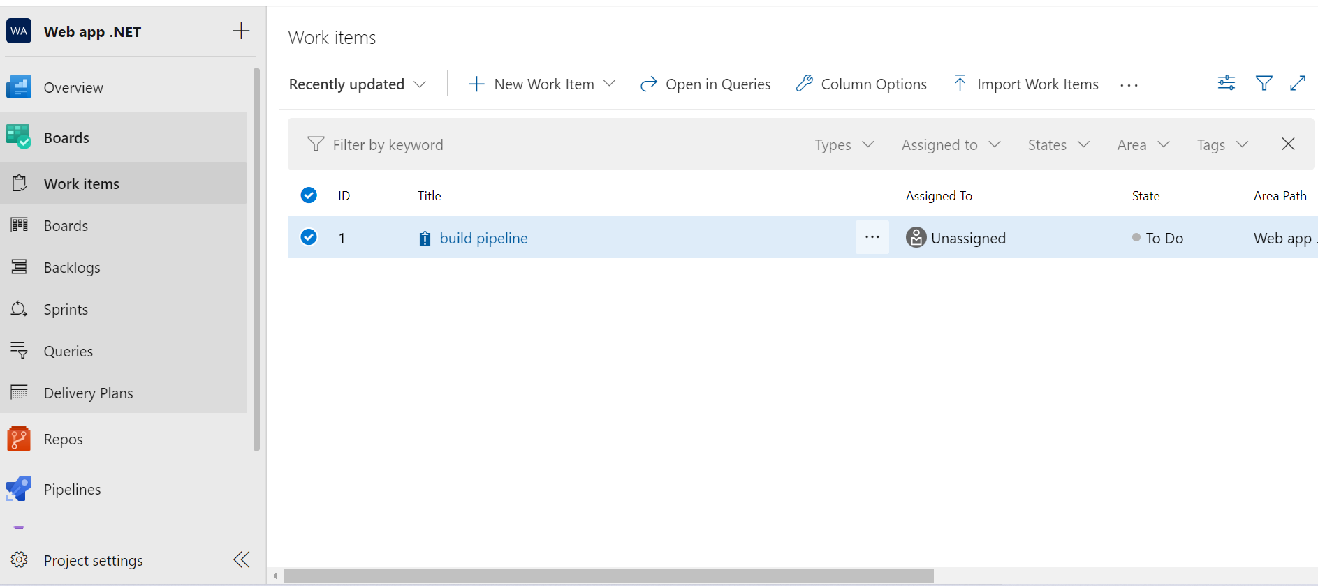

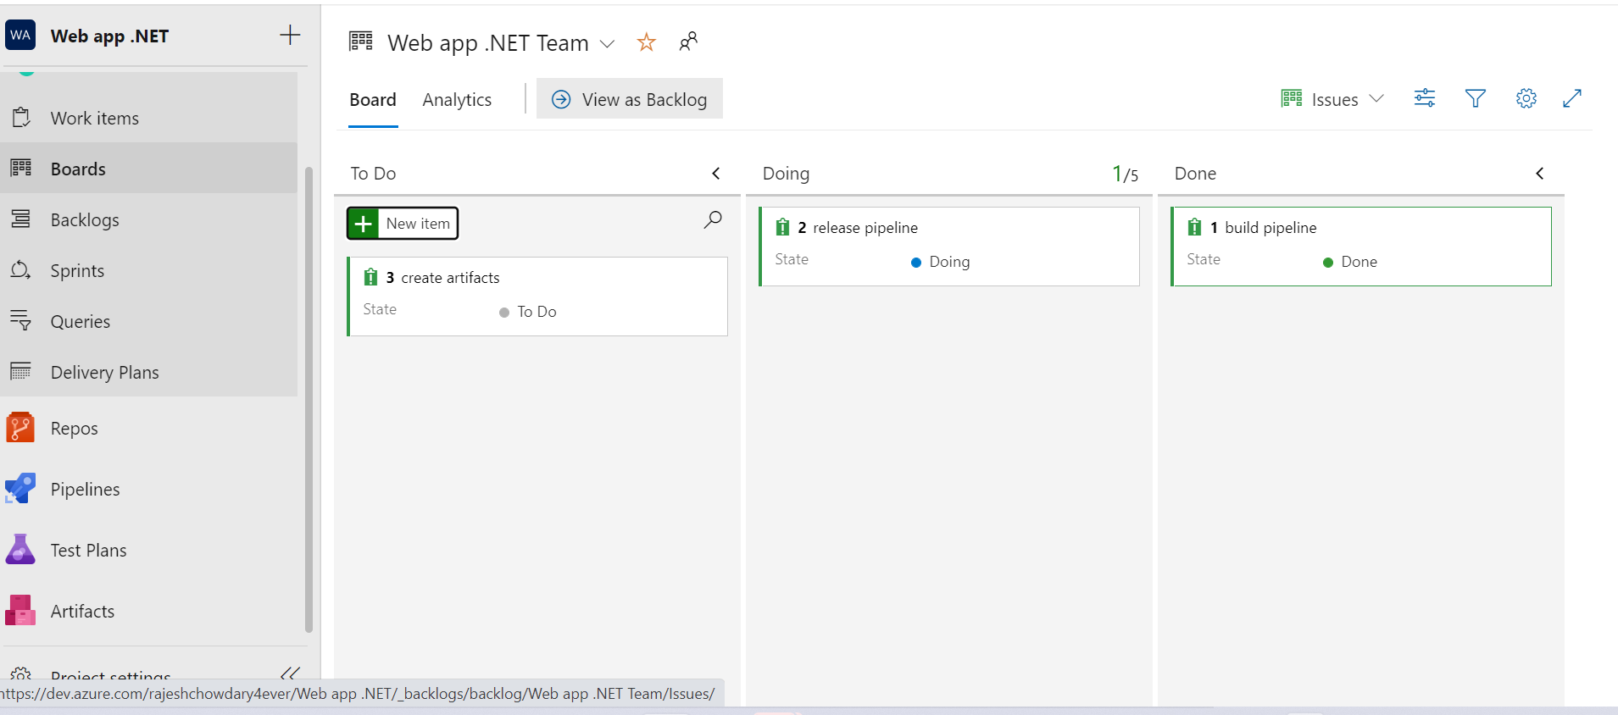

Step 6: Sprints are used for future what are the task should be done in the future we use to make sprint and give it a start time and end time

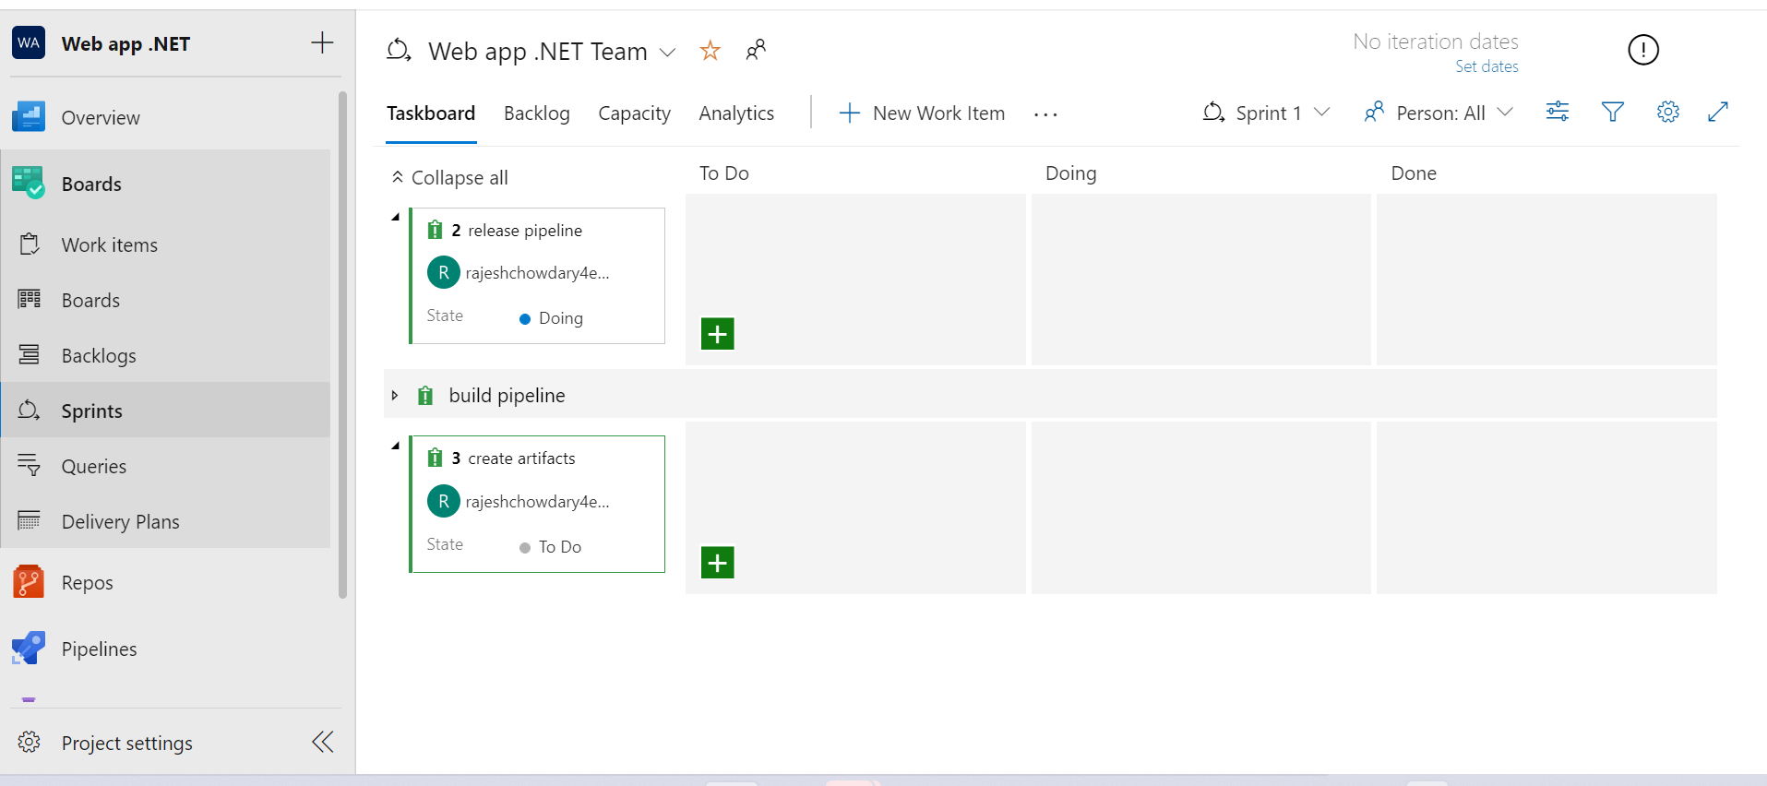

Step 7: Now import the code from Git hub to repos or you can clone it from VSTS.

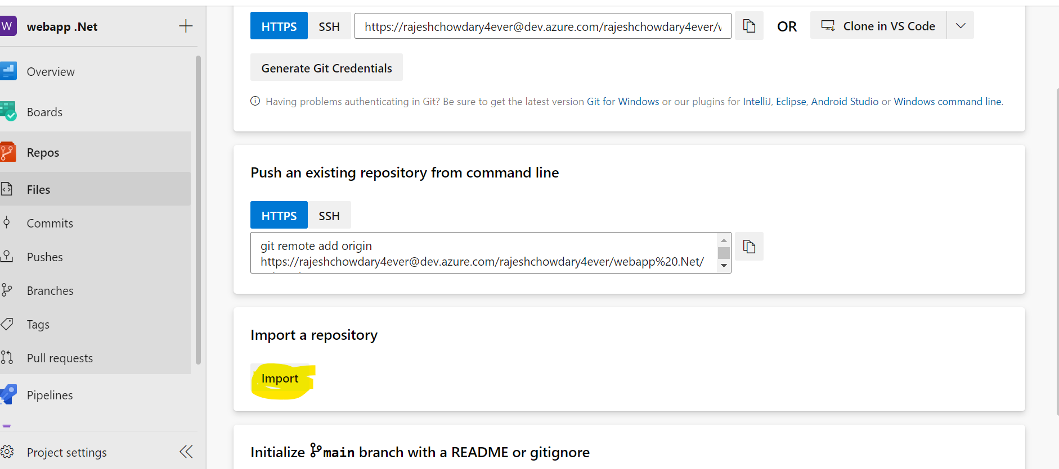

Step 8: For cloning the code in GitHub give the GitHub Url and authenticate it and import the data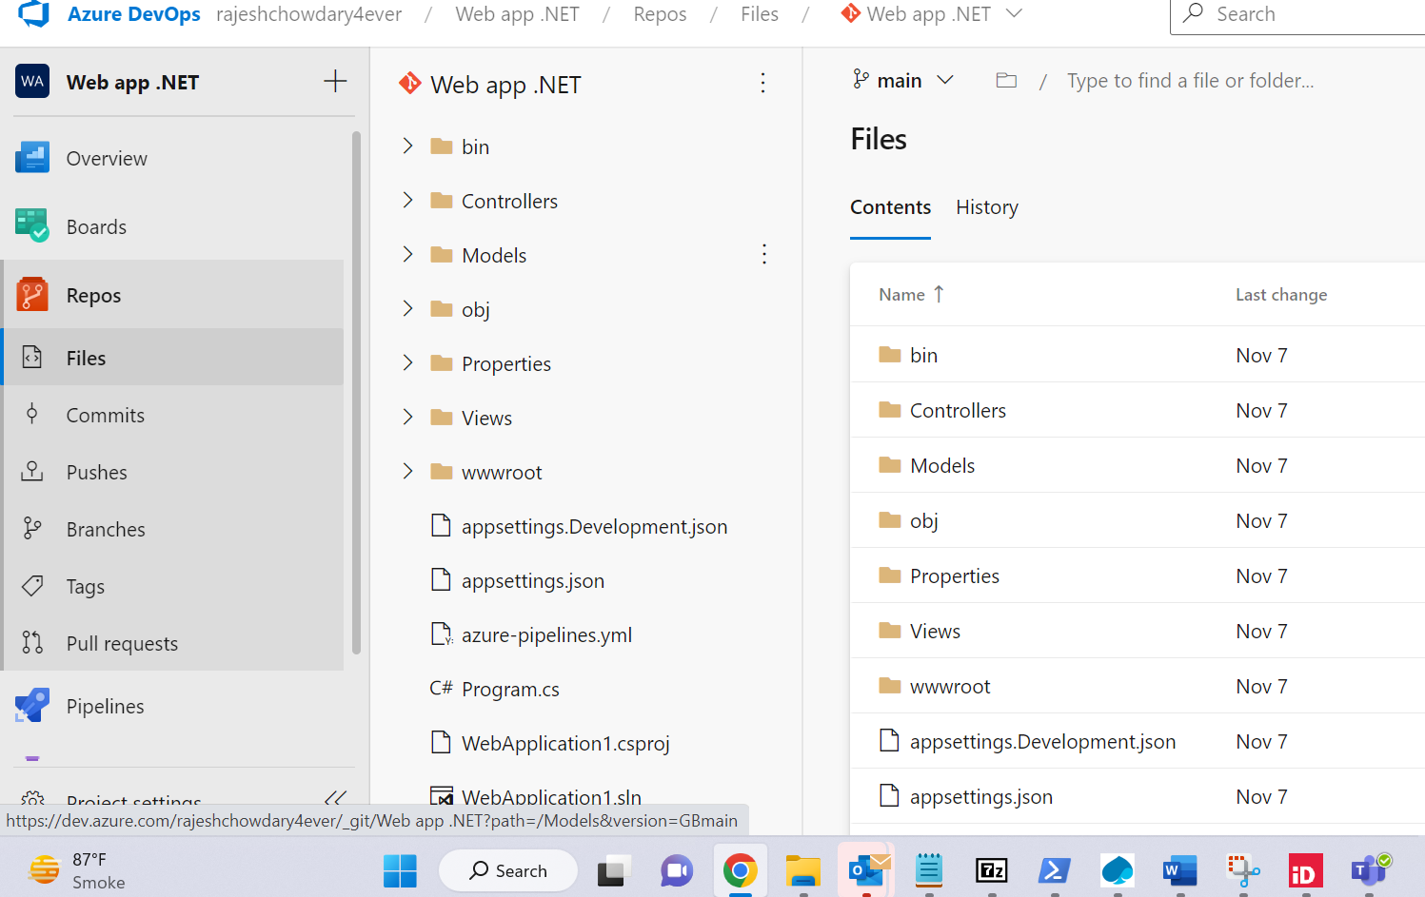

Step 9:Now Create a pipeline using Classic editor without Yaml.

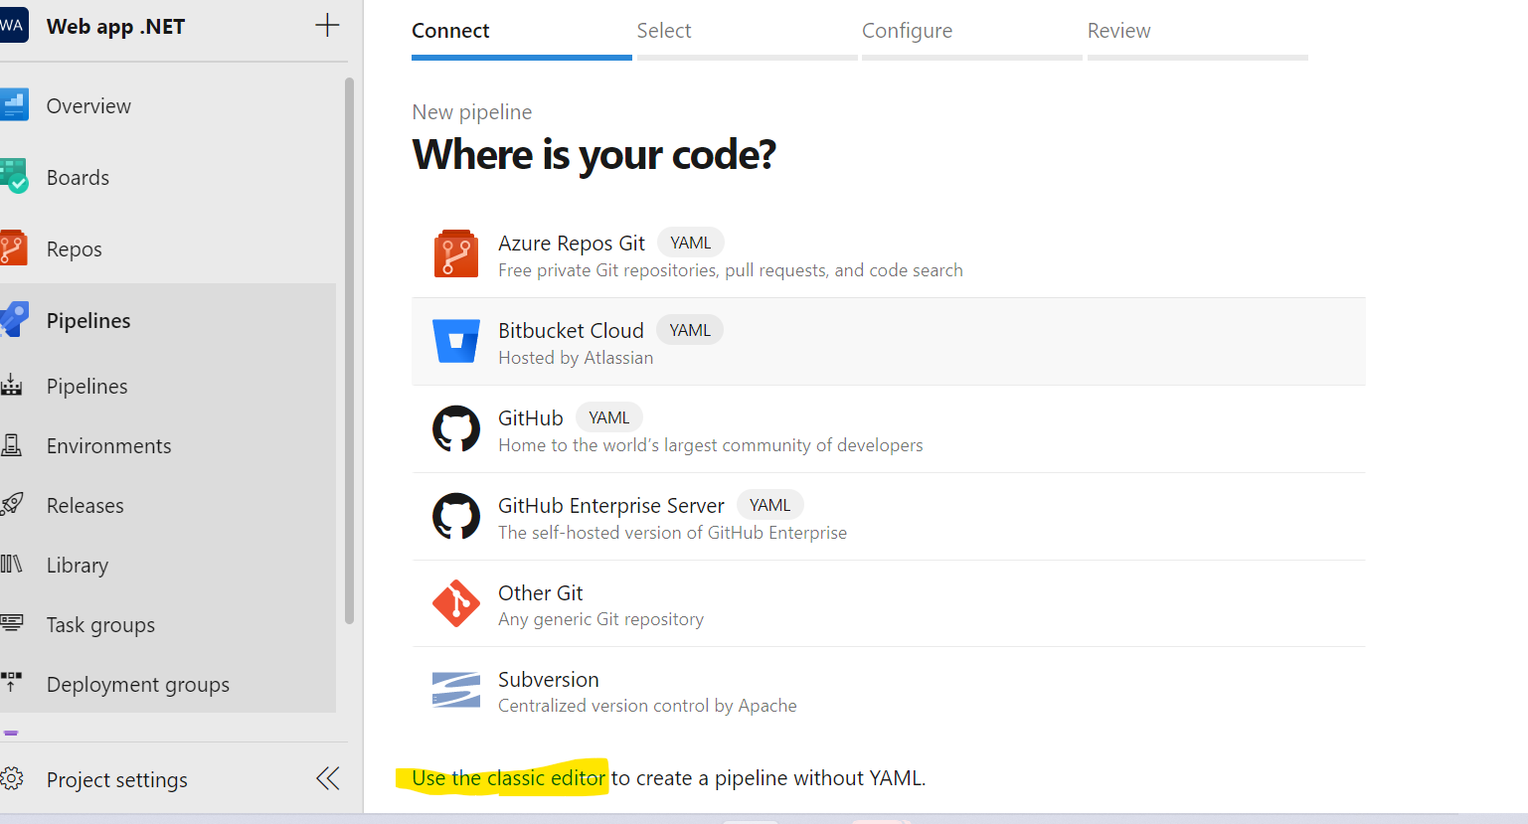

Step 10: Now select the repository and Click on Continue

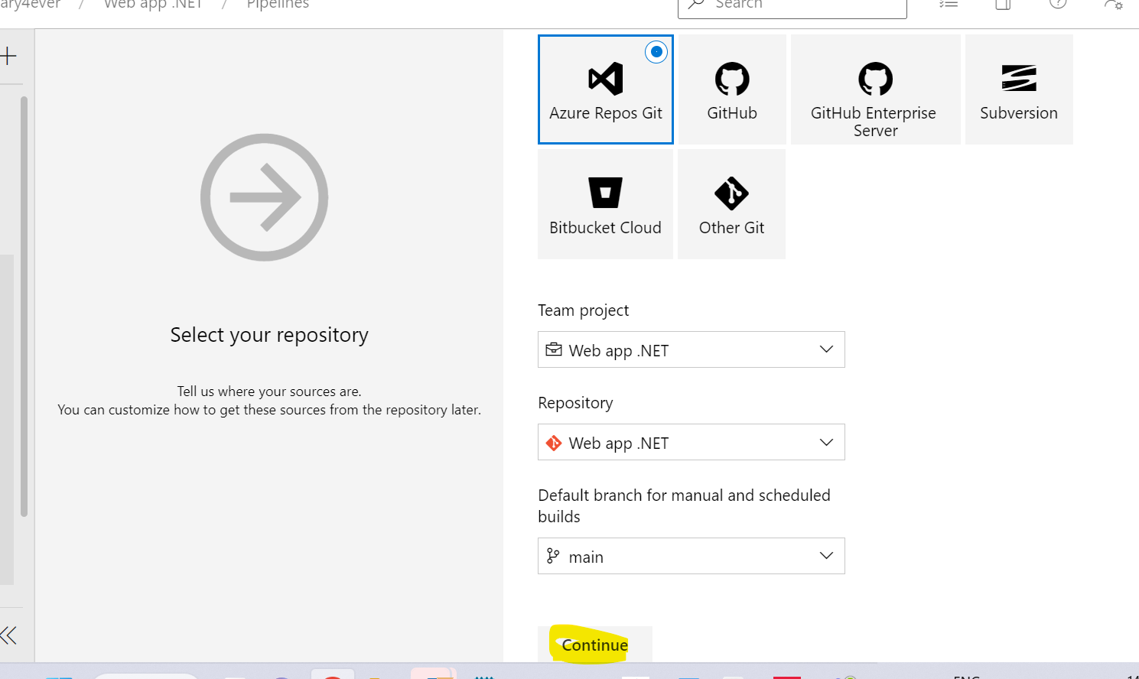

Step 11: Now Select the template According the code and Click on Apply.

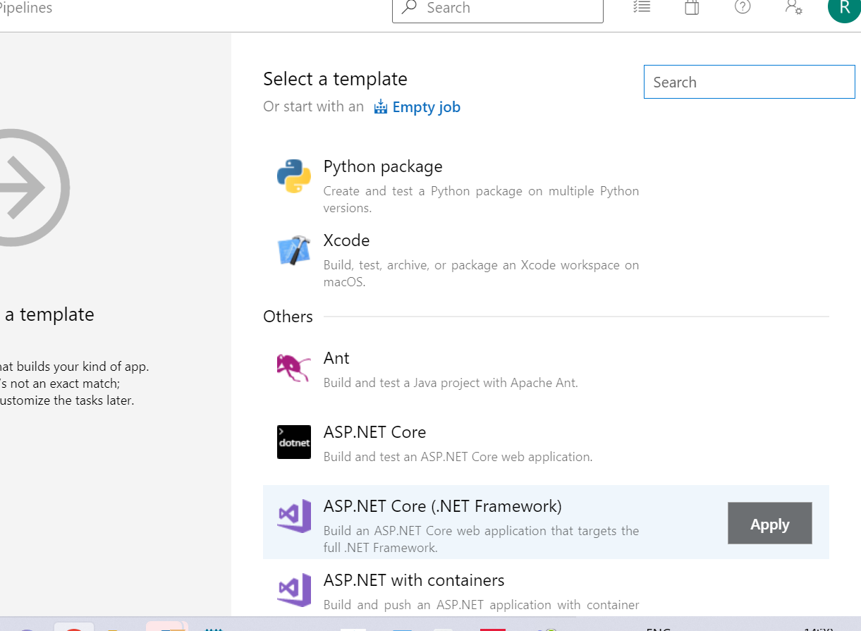

Step 12: Now check the Agent pool In project settings and Add a Agent to the agent pool.

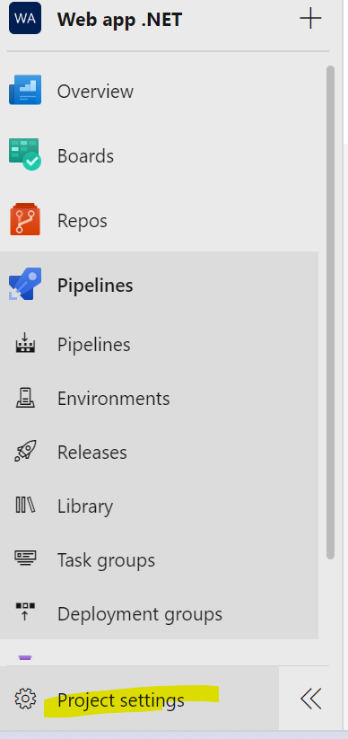

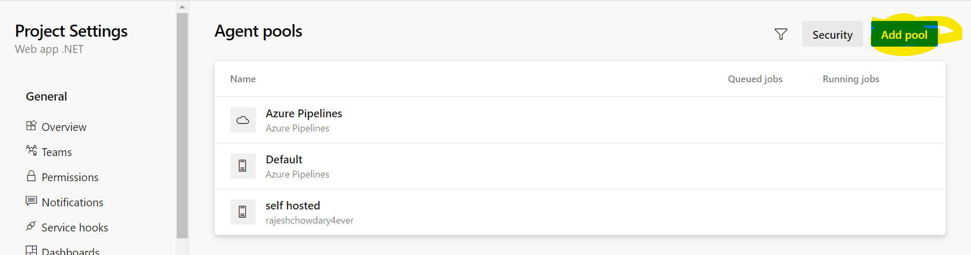

After Creating a Pool .Now Click on New Agent.

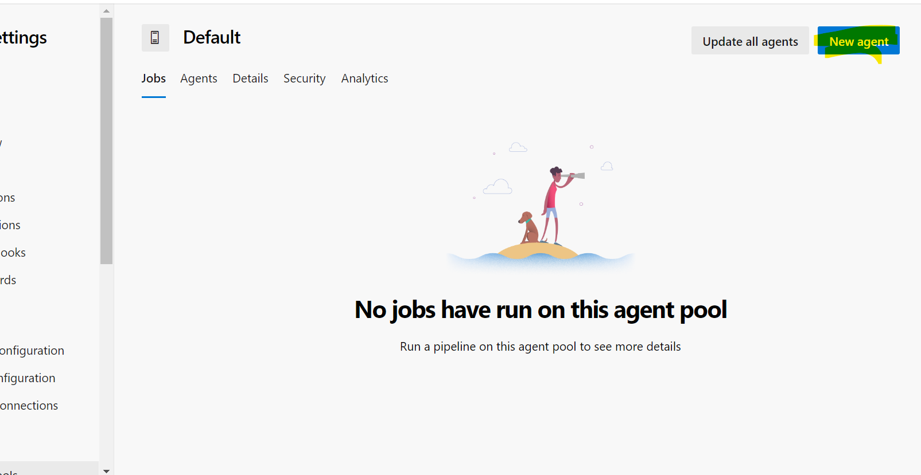

Now Download the Agent and Create it Using the Command and Configure it and run.

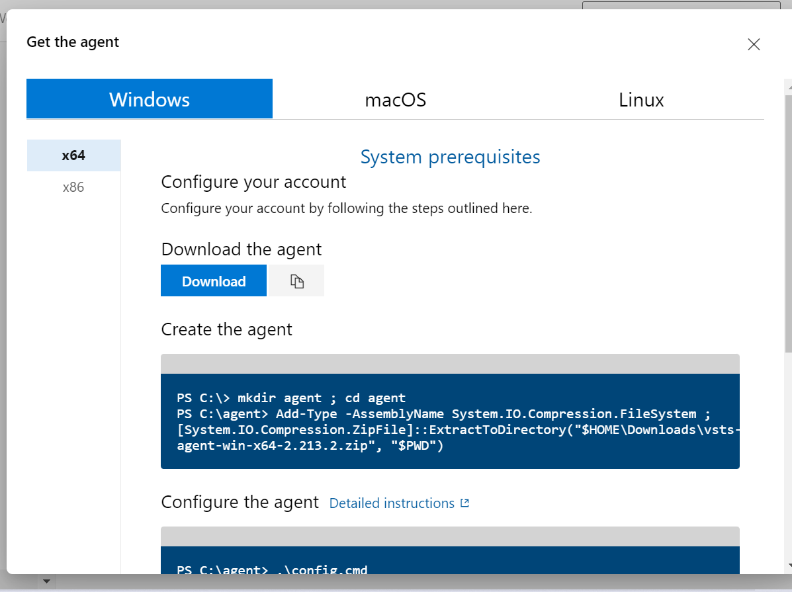

Step 13: Now Select the Created Agent Pool and Click on Save & queue to Build the pipeline.

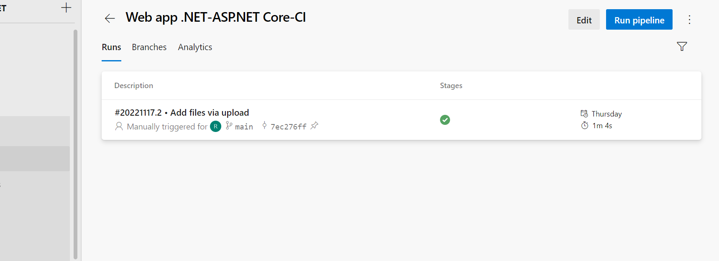

Step 14: Now Click on the Release to Create a Release pipeline.

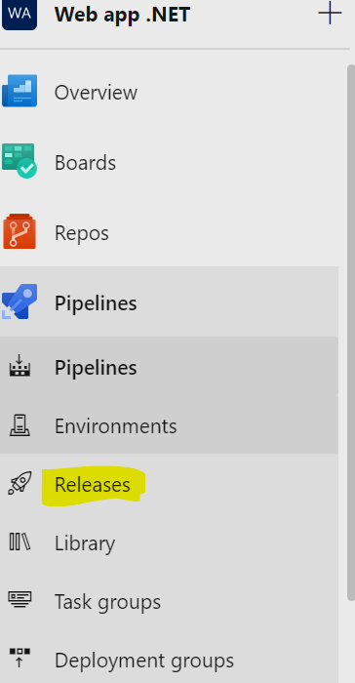

Click on New Pipeline.

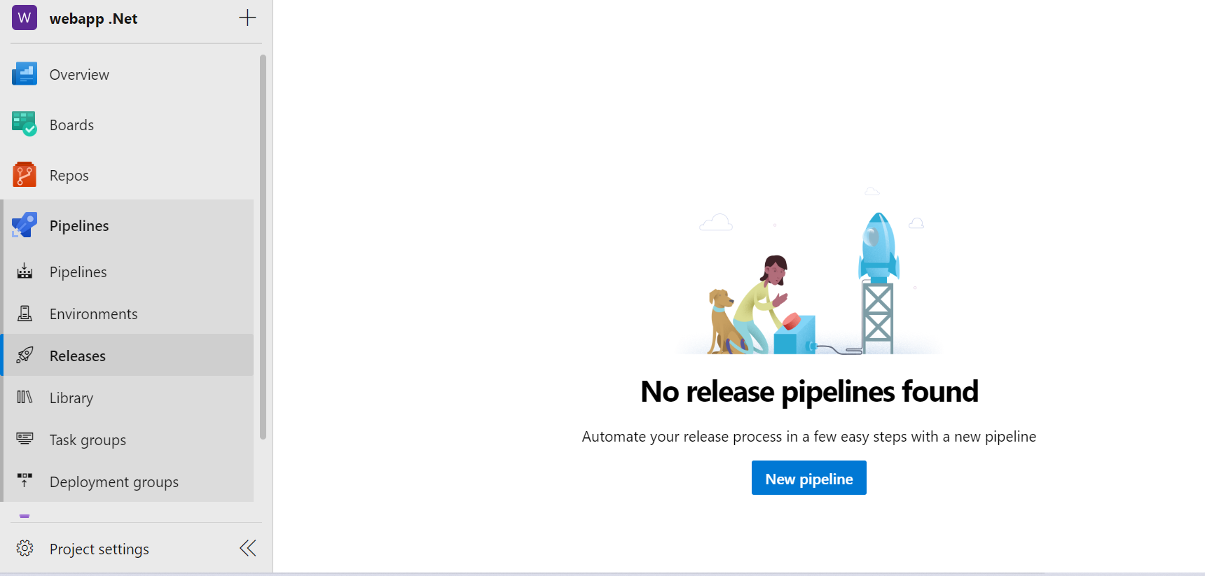

Select the template and in parallel Create a App service in Microsoft Azure portal.

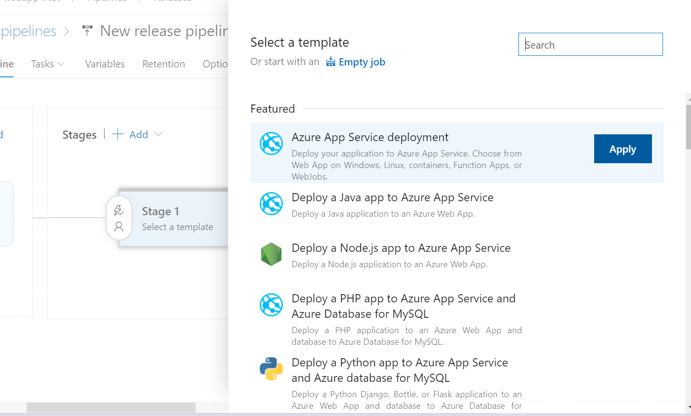

Now Click on Create Release then the release will get created

